We have actually talked quite a lot about the topic and it went all over the place with different themes, such as, what is art, what can we consider being original, being art. We talked about who is the artist in those cases, and is it even ethical to do. I do not have much to add, as we had talked about both the subjects of robots and AI art. And I already poured all my thoughts out about both of those themes. Therefore, I’m once again drawing a blank here.

As I mentioned before, I don’t like AI art, as it feels very bland. To specify, I am not talking about the morphing picture, but the standard AI art. It usually blends in some styles together, so that the subtleties of an author are lost. With some little exceptions, it all looks like a rehearsed drawing of somebody else. Some styles just do not look right. Like the styles of Japanese manga or animation (that I never had seen separated in the AI art form, it’s always looks the same)

The same with comics, most of the AI generated art that I see in this style tries to mimic old-school style of comics, the likes of first dc or action comics.

I feel the need to put in some art styles that I love, and do not see replicated in AI art form at all.

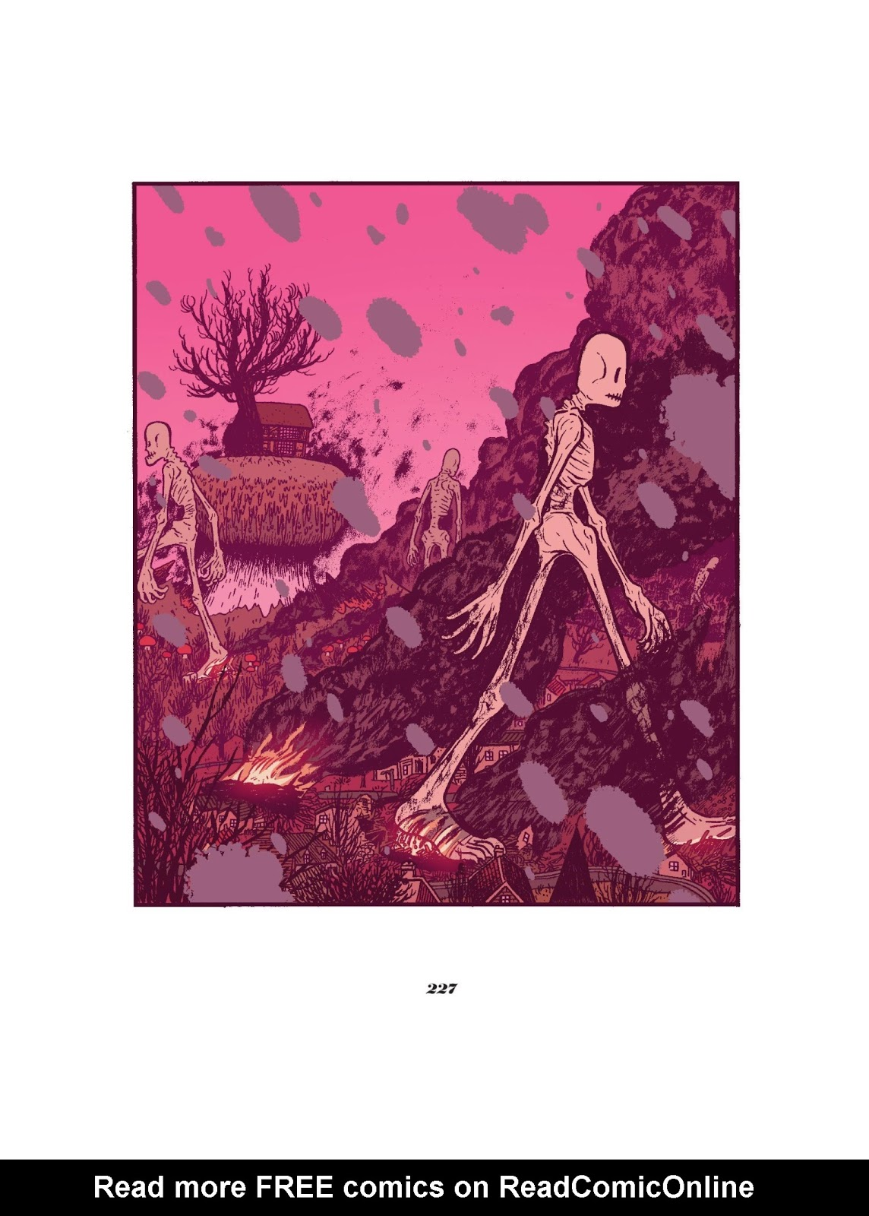

From “Seconds”. Bryan Lee O'Malley

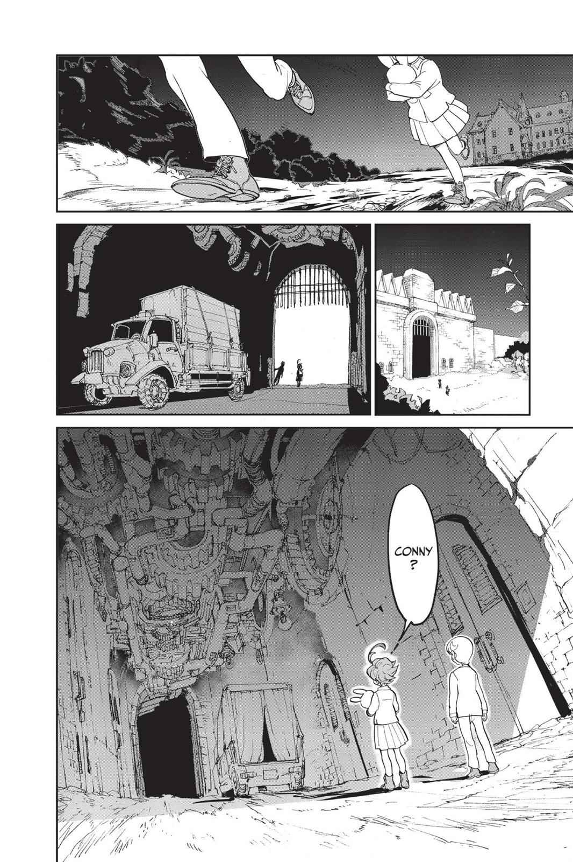

Page from “Promised Neverland”



Small crop from “Ghost in a Shell”

Will it put people out of the job? After our studies, I actually can see that happen. Am I okay with it? No, absolutely not. For now, AI artists, if we can call them that, are made on other people’s works (which is very unfair towards the original artists) and are completely void of any creativity. If more people from different industries start to use AI art, instead of real artists, I can imagine that in a near future we will see a decline in original and new ideas in movies, shows, games and so on. I think that, in order to protect artists and save their workplaces, we need to:

A) Get rid of their works from the AI databases

B) Invent some new laws to deal with this sort of thing.

In my opinion, AI art should be used only as a tool for an artist. It should only give artists ideas or possible looks for their work, it should not replace artist.

At least they should not make this software readily available to the public or testers.

I understand, that this point of view sounds completely different from the ones that I described in the previous essays on driverless cars and robots. But the thing is, whenever I think about those situations, they rarely introduce creativity into the picture. Drivers are not creative, unless they are tuning their cars or planning a route. Other than that, their work is void of creativity. Artists, however, put their soul, experience and twists in their work, most of the art pieces are unique. And I don’t think that an artificial artist, with no twists, passion or inspiration for its work can replace a real one. Creativity, for now, stays exclusively a human trait. And I think that’s for the best.